P.A.D.S. NEWS
MARCH 2013

Firstly, thank you to those members who braved the weather and went to the 4-Way Match on Sunday 23rd March. There were only 7 of you who did go (Peter Walker, Julie Goddard, Ann Smart, James Halton, Karen Butler, Ann Parker and Steve Tibbett) and you did really well – so well that Packington got 3rd place overall with 38 points.

Results are:
1st Small 1-2 jumping Julie Goddard with Holly 1st Small 1-2 Agility Julie Goddard with Holly
2nd Small 1-2 jumping Ann Smart with Tigger

1st Large 1-2 Jumping James Halton with Olly 1st Large 1-2 Agility James Halton with Olly

1st Std. 1-2 Agility Karen Butler with Holly 1st Med 3-4 Jumping Peter Walker with Kalli
2nd Med 3-4 Agility Peter Walker with Kalli
Final points:
Chipping Norton 70 : Leamington 57 : Packington 38 : Bretford 10
…………………………………………………………………

At other shows, you seem to be doing very well, so

CONGRATULATIONS to

Peter and Kalli who now move up to Grade 4
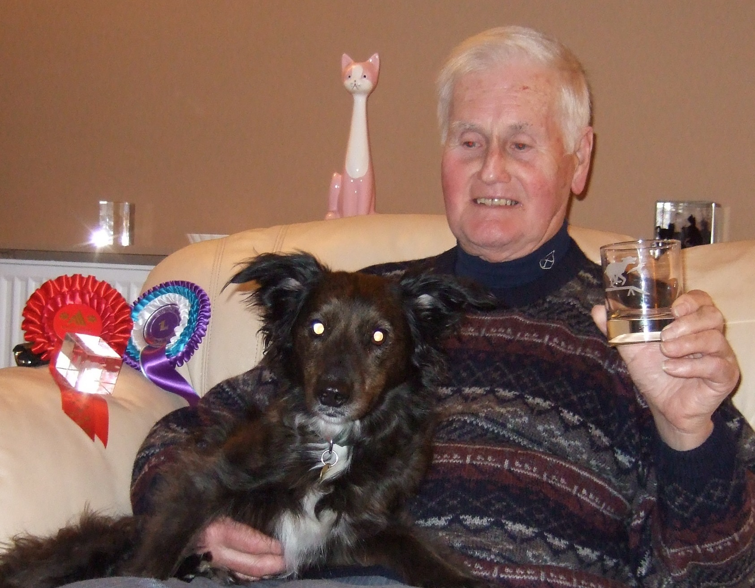
1st in Medium G1-4 graded Agility at Adams Jan show – into Grade 4.
1st in Medium G1-4 combined Agility at Gun Dog show.
1st in Medium G 2-3 Agility at March Bitz ‘n Bobz
2nd in Medium G2-3 Agility at Bitz ‘n Bobz February Show
Clear Round in Medium G1-3 combined Agility at Adams Jan. show.
Clear Round in Medium G1-3 graded Jumping at Adams Jan. show.
Clear Round in Medium G1-4 combined Jumping at Gun Dog Show.
Clear Round in Medium G1-7 combined Steeplechase at Gun Dog show.
Clear Round in medium G2-3 Agility at March Bitz ‘n BobzBitz
Clear Round in Medium G2-3 Steeplechase at March Bitz ‘n Bobz

Ann and Desi who have moved up to Grade 4 on points
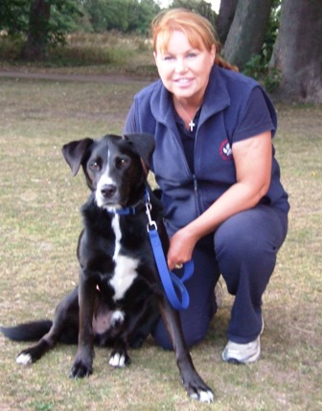
Page 2
Beryl and Molly 1st in Large G1 Agility at February Bitz ‘n Bobz qualifying for the Final
2nd in Standard G1 Agility at March Bitz ‘n Bobz
3rd in Stamdard G1 Agility at March Bitz n Bobz
5th in Large G1 Jumping at March Bitz ‘n Bobz

Julie and Holly 2nd in Small G1 Agility at Bitz ‘n Bobz January show.

Debs and Molly 2nd in Large G3-4 ccombined Jumping at Gun Dog show
4th in Large G1-7 Steeplechase at Gun Dog show
5th in Large G3 Jumping at Easter Egg’gility
7th in Large G1-3 Easter Egg Challenge at Easter Egg’gility
8th in Large G1-3 Jumping at Easter Egg’gility
10th in Large G1-3 Jumping at Easter Egg’gility
Clear Round in Large G1-7 Helter Skelter at Easter Egg’gility
Clear Round in Large G3 Agility at Easter Egg’gility

Greg and Max 5th in Large G1-3 Agility at Easter Egg’gility

Sue and Skye 9th in Large G1-3 Agility at Easter Egg’gility
10th in Large G1-3 Jumping at Easter Egg’gility
Clear Round in G1-3 at Easter Egg’gility

Debs and Drift 5th in Large G3 Agility at Easter Egg’gility
8th in Large G1-3 Jumping at Easter Egg’gility
Clear Round in Large G3-4 Jumping at Gun Dog Show
Clear Round in Large G1-7 Steeplechase at Gun Dog show
Clear Round in Large G1-3 Jumping at Easter Egg’gility

Beryl and Sam Clear Round in Large G0 Jumping at February Bitz ‘n Bobz
Clear Round in Large G0 Agility at March Bitz ‘n Bobz

Chris and Jeepster Clear Round in Small G1-3 Agility at Easter Egg’gility
Clear Round in Small G1-3 Jumping at Easter Egg’gility

It is Competition Night tonight – 4th April. Alan Preston will be your judge so make sure you come along to win points for the Club League.

Thursday, 25th April will be the final training at Swallowfield this year so we will need to pack the trailer after training. Consequently, as many members as possible will be required to help us to do this. Again, when the trailer arrives at Dorridge Park on 2nd May, we will need as many members as possible to help unload it so there will probably not be much training that night. You could use the time to give your dog some exercise in the Park after everything is taken from the trailer and put away in the container. The more of us there are to do this job the quicker it will be finished and the less work for everyone concerned!!!!!!!!!

Once back in the Park, training starts at 7.15 p.m. for everybody who wants to train. Please try and keep your dogs from barking all the time. It is part of their training to be quiet when you want them to be.

SHOW DATES FOR YOUR DIARY:
This is a list of shows, mostly local, at which quite a few members will be present so you will always know someone there:
4th April Competition Night at Swallowfield 8.00 p.m.
4th and 5th May Dordale Show – Top Barn - (entries closed)
6th May Warwick Races, Warwick Racecourse – (entries close 2nd April)
11 and 12th May Beacon Show, Old Veseyans RFC, Streetly – (entries close 29th March)
17th – 20th May Adams Show, Catton Hall, Alrewas (entries close 5th April)
18th May Worcester Show, Top Barn, Holt Heath (entries close 5th April)
27th May PACKINGTON SHOW, Barker Butts RFC, Coventry (entries close 9th April)
1st/2nd June Wye Valley Show, Monmouth
6th June New Beginners Night commences.
8th/9th June North Derbyshire Show
8th June Bitz ‘n Bobz, Coventry
9th June Chipping Norton
15/16th June Golden Valley Show, Top Barn, Holt Heath.
27th June Smart Paws competition at Rugby
4th July Annual Barbecue and Competition Night
21/22nd September Bromsgrove Show, Top Barn, Holt Heath (We have to run a ring on Sunday 22nd)

Page 3

You will see from the above that our Show is held on May 27th. Help is expected from ALL MEMBERS as it is the profit from this Show that supports the Club financially. Debbie and Greg will shortly be asking you what job you would like to do at the Show so if you know what you would like to do please let them know asap or else you may well get a job you don’t want to do!! Full training will be given for all the jobs we need you to do so don’t worry that you won’t be able to cope. Basically the jobs requiring help are:

Scrimer When a dog leaves the start line, the automatic timing starts and the Scrimer
then watches the Judge and marks down any faults given; at the end of the dog’s
run the Scrimer writes down the dog’s time together with the faults, on the pad provided.

Scorer Sits at the score table and marks the dog’s score on the sheets provided. The
Padder will bring the result of the dog’s round to the Scorer.

Padder Takes the pad from the Caller to the Scrimer and then, when that is completed, takes
it to the Scorer.

Caller Has a list of competitors in his Ring and will call up to certain running numbers to keep
the queue going and ensure the queue is not too long.

Leads Takes the dog’s lead from the start of the course to the end of the course, ready and
waiting for the dog when he finishes his run.

Poles Replaces poles that the dogs have dislodged.

…………………………………………………..

You will also see that we have been asked to run a ring for Bromsgrove on 22nd September (Sunday). This is in return for them running a ring for us at our show. If you are not going to Bromsgrove on both days but would like to go on one, perhaps you would bear this in mind. In return for helping run the ring, we are given refreshments throughout the day, lunch and ringside parking so that you don’t have to leave your dog far away. You will also be given plenty of time to exercise your dog and run him in the competitions. Please let Debbie know if you can help.

……………………………………………………………

Our New Beginners Course starts on Thursday, 6th June. If you know of anyone who would like to take up Agility with their dog, please let them know.
…………………………………………………………….

Annual Barbecue and Competition Night will be on Thursday 4th July – more points to win in the Club League.
Food and soft drinks supplied by Packington. Friends and family welcome. Rosettes and trophies.

……………………………………………………………

When training, please ensure that you help put equipment in and/or out and don’t leave it to the few old faithfuls who seem to get the job both ends each week. It really isn’t fair. So, lots of help getting equipment in and out and also attempts to stop your dogs barking non-stop, and we will all be happy.

…………………………………………………………

Finally, I have had a request from a former member, as follows:

“I was just wondering if you or someone you know would be willing to foster a 4 year old male terrier x from dogs trust Roden. He is getting so stressed out in kennels he is injuring himself. He is good with dogs. Don't know much else about him but I can put you in touch with someone who does if you can help.”

If anyone can help, please email sabrina williams <sabtwill@yahoo.co.uk>

THE ENd

